PANDA
I am looking for a permanent home
I was imprisoned every day in a hole in a fence on a very short chain, in all weathers, and all I had for a bed was a sheet of sloping old rusty metal.
Look at me then:
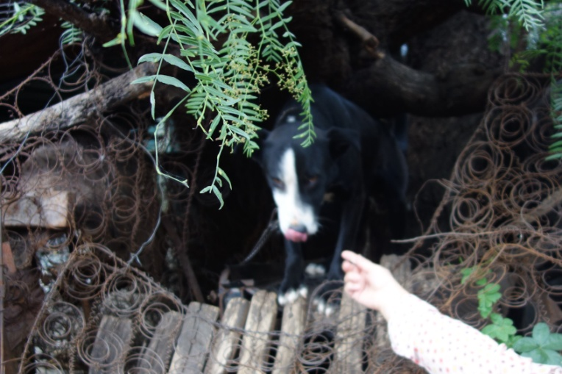
Sue and Geoff rescued me and took me to the vet where I was neutered and had all the necessary shots. Sue shampooed and brushed me and now I look very handsome and happy. I am intelligent and very friendly too.
Look at me now:
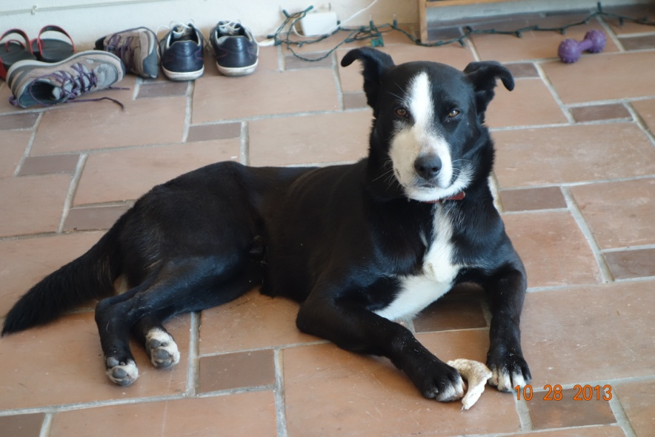
Please email: info @sueparry.co.uk or call 473 103 3725 (Sue)

